### Paper Snow Globe Slice form for Christmas Gift Giving

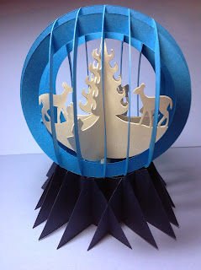

Snow Globe Slice form

This snow globe is adorable. It took me hours to design but it was worth every second. This is a wonderful Christmas present. I am sure that any recipient would love to receive it. It can be mailed as the base is not glued to the globe and everything can fold flat.

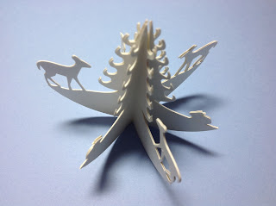

Glue the six scenes together as shown

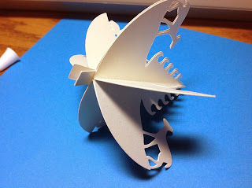

Add the tabs to the center of the scenery as shown.

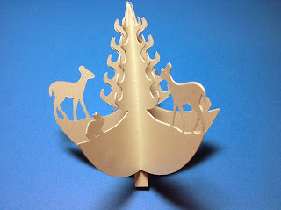

Completed scenery

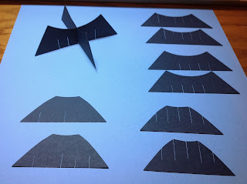

Arrange the snow globe base pieces according to size and type of slit.

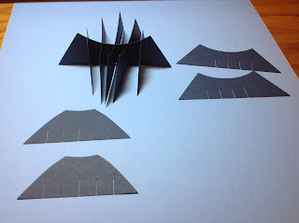

Attach all of the top facing slits first.

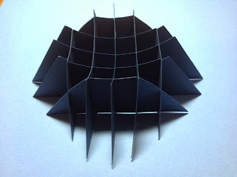

Completed base.

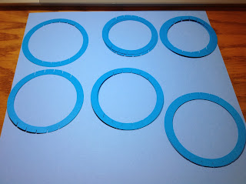

Arrange the globe slice forms according to size and slit position.

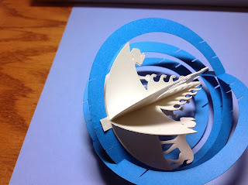

Glue the scenery to the center slice form as shown. Be careful not to cover the slit.

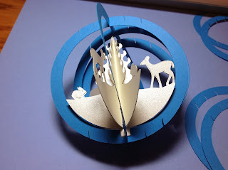

Another view of the attached scenery.

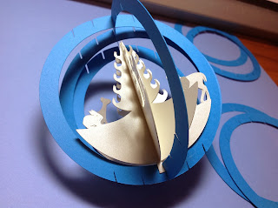

Continue adding the slice forms.

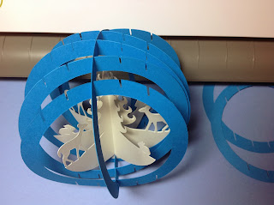

I like to do all of the upward facing slits first.

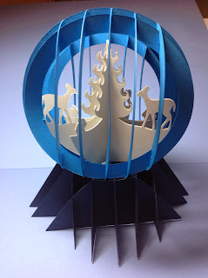

Completed Snow Globe

**Math used for the base were cone minus sphere equations:**  
**Cone slice z = (height of cone/radius of base) x sqrt (x^2 + y^2)**  
**Sphere slice x^2 + y^2 + (z - translation distance) ^2 = (radius)^2**  
**Translation distance = (height of cone cutoff) - (sphere radius) - (sink height)**  
**Height of cone cutoff "a" comes from solving: (radius of bottom) / (radius of top) = ((height of base)+a)/a**  
**Sink height = radius of sphere - h**  
**h comes from solving h^2 + (radius of top) ^2 = (radius of sphere) ^2**